**R Programming _Basic_Task 1 - ANSWERS**

1. **Vector Recycling**

When applying an operation to two vectors that requires them to be the same length, R automatically recycles, or repeats, elements of the shorter one, until it is long enough to match the longer Vector.

**Example 1:**

Suppose we have two Vectors c(1,2,4) , c(6,0,9,10,13), where the first one is shorter with only 3 elements. Now if we sum these two, we will get a warning message as follows.

> c(1,2,3) + c(5,0,4,10,11)

output:

[1] 4 2 7 11 13

Warning message:

In c(1, 2, 3) + c(5, 0, 4, 10, 11) : longer object length is not a multiple of shorter object length

Here R , Sum those Vectors by Recycling or repeating the elements in a shorter one, until it is long enough to match the longer one as follows..

> c(1,2,4,1,2) + c(6,0,9,10,13)

output:

[1] 7 2 13 11 15

1. **Inner Multiplication**

* **Usage:** Multiplies two matrices, if they are conformable. If one argument is a vector, it will be promoted to either a row or column matrix to make the two arguments conformable. If both are vectors of the same length, it will return the inner product (as a matrix).

**Program:**



Output:

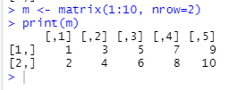

1. **Outer Multiplication**

* **Usage:** is function applies a function to two arrays.

**Program:**

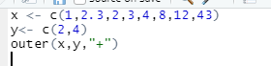

Output:

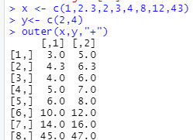

1. **Funcations**

**4.1. sample()**

* 1. **Usage:** 
     1. To select a number of elements out of a Vector.
     2. There are 2 types of sample: Sample with replacement and Sample without replacement.
     3. Sample with replacement allows us to select the same element from the vector again.
     4. Sample without replacement is the default function. It does not allow selecting the same element again and again
  2. **Program**:

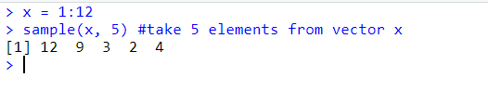

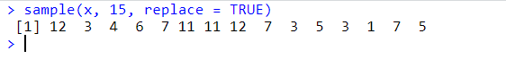

* **Warning:**
  + If our data set **x** has only one value. Ex: x = 4. ***sample()*** will interpret it as a vector that contains (1, 2, 3, 4)
  + **Program**:

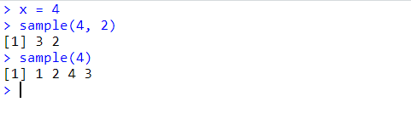

**4. 2. seq()**

* + **Usage:** to create a sequence of numbers.
  + **Program:**

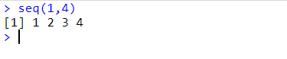

*by=2* increments number by 2.

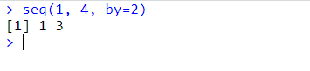

*length=6* tells the function to create 6 elements

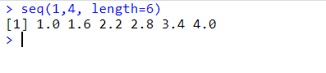

**4.3. rep()**

* + **Usage:** to repeat the number
  + **Program:**

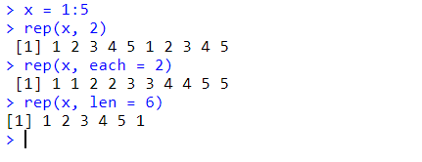

**4.4. round()**:

* + **usage:** to round a number
  + **Program**:

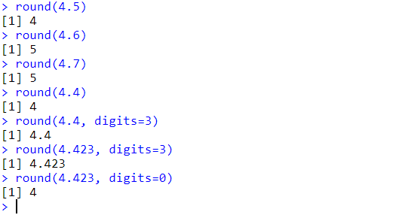

**4.5. factorial()**

* + **Usage:** to calculate factorial
  + **Program:**

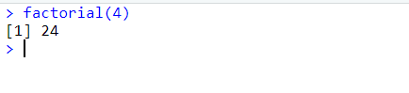

**4.6. is()**

* + **Usage:** Functions to test inheritance relationships between an object and a class or between two classes (extends).
  + **Program:**

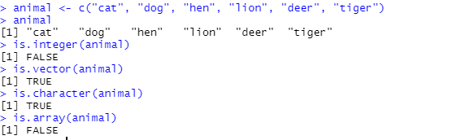

**4.7. mean()**

* **Usage:** It is calculated by taking the sum of the values and dividing with the number of values in a data series.
* **Program:**

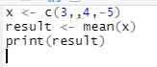

Output:



**4.8. set.seed()**

* **Usage:** The use of set.seed is to make sure that we get the same results for randomization. If we randomly select some observations for any task in R or in any statistical software it results in different values all the time and this happens because of randomization. If we want to keep the values that are produced at first random selection then we can do this by storing them in an object after randomization or we can fix the randomization procedure so that we get the same results all the time.

**Program:**



Output:



1. **Subset**

* **Definition:** Subsetting in R is a useful indexing feature for accessing object elements. It can be used to select and filter variables and observations. We can use brackets to select rows and columns from your dataframe.

**EXAMPLE:**

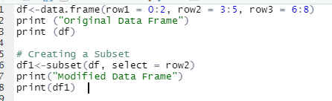

Output:

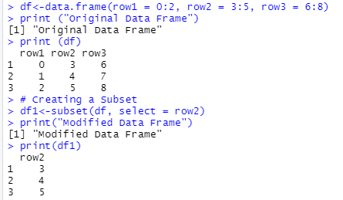

1. **Write a program to calculate the BMI rate?Get the user input & Result should be in integer.**

* **BMI rate calculation:** is the formula to find the number of calories.
* Normal weight = 18.5-24.9; **Overweight** = 25-29.9; **Obesity** = **BMI** of 30 or greater.

Program:

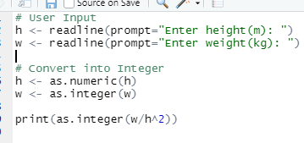

Output:

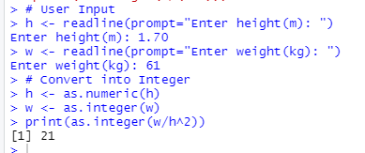

1. **Create a function to calculate the BMI Rating? Result should be in integer?**

* **BMI rate calculation:** is the formula to find the number of calories.
* Normal weight = 18.5-24.9; **Overweight** = 25-29.9; **Obesity** = **BMI** of 30 or greater.

Program:

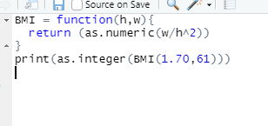

Output:

